The following questions are based on the podcast entitled:
“Digital Banking in Malaysia – Opportunities & Challenges”
Podcast link:
https://open.spotify.com/episode/5sbavIDWIUMWaKZ1AhxmEJ?si=QXe3udwrR2CdW_8rgmAnaA

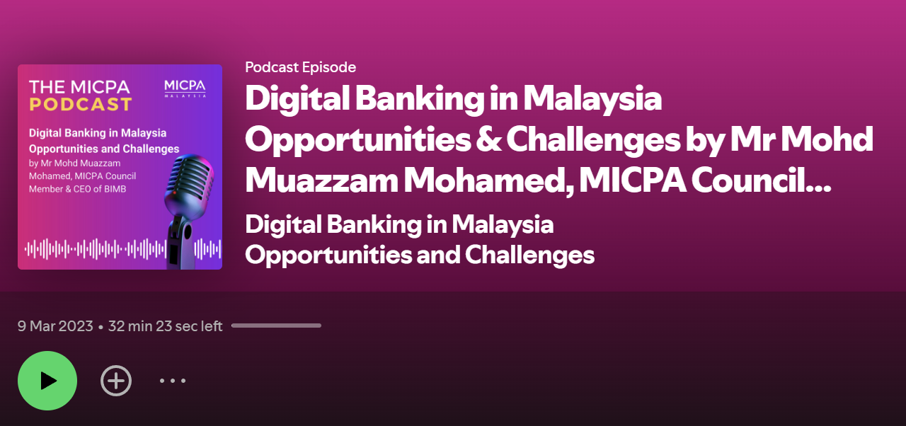

1. With nearly 96% banking penetration in Malaysia, the question arises: where does the gap exist, and what makes digital banking essential for the country?

Answer Guide:
- While most individuals hold both bank and savings accounts, not all customers currently have full access to comprehensive banking solutions.
- Financing services are not universally extended to all bank account holders. Banks willingly accept deposits into both current and savings accounts from individuals across diverse economic segments.
- However, it is imperative for banks to exercise diligence in verifying the legitimacy of the deposited funds. They cannot indiscriminately accept money from everyone, as precautions must be taken to prevent potential involvement in money laundering activities.

2. When a bank extends loans to customers, it conducts its own assessment, and not everyone is afforded the same opportunity. What are the reasons highlighted by the speaker?

Answer Guide:
- The bank conducts its own assessments and may not extend the same opportunities to everyone.
- This is due to the absence of credit data that reflects financial behavior, a lack of visibility into payment capability, and inconsistent income.
- Lending to individuals or sectors unknown to the bank is considered risky because the bank cannot ascertain their credit standing, which could potentially lead to loan disapproval.
- This situation arises when individuals or sectors lack a sufficient profile and credit history to meet even the minimum criteria.
Why not everyone receives the same loan opportunities?
- Risk Evaluation: Banks need to assess the level of risk associated with each borrower. Individuals or businesses with a strong credit history, stable income, and a proven track record of financial responsibility are generally viewed as lower risk. Those with poor credit histories or uncertain financial situations may be considered higher risk.
- Financial Capacity: The amount a bank is willing to lend depends on the borrower's financial capacity to repay the loan. Those with higher incomes and more substantial assets may qualify for larger loan amounts, while others may be limited based on their financial situation.
- Loan Purpose: The purpose of the loan also influences the bank's decision. Loans for purposes deemed higher risk or lacking a clear financial return may be subject to more stringent evaluation.

3. As an Intermediaries, the banks need to exercise caution when extending loans as they play a crucial role in mobilizing capital to stimulate economic growth. In the context of lending, what considerations lead to the decision to rely on 90 cents from depositors and 10 cents from shareholders for each ringgit loaned?

Answer Guide:
- Banks accumulate deposits from customers who expect the flexibility to withdraw funds at their convenience.
- As intermediaries, banks bear responsibility for the money they lend and are capable of full collection.
- Moreover, banks are obligated to reimburse depositors promptly upon request, ensuring that the capital they mobilize contributes to fostering economic growth.
- By sourcing most funds from depositors, banks can leverage their customer base, and the capital entrusted to the institution. This approach is generally considered more stable and less risky, as deposits are typically viewed as a more reliable and constant source of funding.

4. If customers are unable to secure a loan from the bank, they often resort to alternative non-banking institutions for borrowing. Explain the examples highlighted by the speaker.

Answer Guide:
- To maintain a balanced approach to risk, banks may find it challenging to extend services to new or high-risk customers.
- Consequently, some of these customers might not secure loans from the bank and may turn to alternative sources of financing, such as non-banking institutions like licensed money lenders.
- However, a significant portion in Malaysia indicates that many may resort to unlicensed money lenders, such as Ahlong.

Why Do People Choose Unlicensed Money Lenders?
- Unlicensed money lenders may be more accessible in certain areas or communities, offering convenient locations and flexible hours of operation.
- They often have less stringent requirements compared to banks and licensed lenders, making it easier for individuals with limited or poor credit history to obtain loans.
- These lenders may provide quicker loan approval processes than traditional financial institutions, which can be crucial for individuals facing urgent financial needs or emergencies.
- Some individuals may not qualify for loans from licensed institutions due to factors such as lack of collateral or stable income. In such cases, unlicensed money lenders may appear to be the only available option.
- People may prefer dealing with unlicensed lenders to maintain a level of privacy, as these lenders often operate discreetly and may not require extensive documentation or background checks, providing a sense of confidentiality.
- Additionally, unlicensed money lenders may be more flexible in offering smaller loan amounts, suitable for those seeking modest sums without undergoing the formalities required by licensed institutions.

5. What factors inspired Bank Negara Malaysia to promote improved financial inclusion by considering the approval of licenses for digital banks?

Answer Guide:
- Bank Negara Malaysia (BNM) is committed to increasing financial inclusion, especially during challenging times such as the COVID-19 pandemic and geopolitical crises.
- The rise of the digital economy is transforming how businesses operate.
- Many individuals, particularly younger generations, now earn income through unconventional means, often lacking the stable income profiles traditionally preferred by banks.
- Prior to the COVID-19 pandemic, BNM data showed that one in four Malaysians worked as freelancers without holding full-time jobs.
- Recognizing this changing employment landscape, BNM is issuing licenses for digital banks to better adapt to new income patterns and promote a more inclusive financial system.
- BNM has established clear mandates and requirements for approving digital bank applications, aiming to enhance the financial well-being of individuals and sectors, thereby achieving greater financial inclusion.

6. Who stands to benefit the most from digital banks, which present
significant opportunities for promoting greater financial inclusion?

Answer Guide:
- Micro businesses such as SMEs, individuals, freelancers, and solopreneurs who participate in the gig economy often face challenges in obtaining loans.
- Many of these applicants have low credit scores or lack a credit track record.
- As a result, the loan rejection rate is high. According to statistics from Bank Negara Malaysia (BNM), only 33% of loan applications from the micro-economy segment are approved. In other words, out of every three applicants, only one receives approval, which is a very low rate.
- To address this issue, it is important to understand user preferences and credit behavior by analyzing alternative data. Utilizing artificial intelligence (AI) to forecast expectations and gain insights about applicants can help. AI-powered advanced analytics, supported by machine learning algorithms, can accelerate loan decision-making and assist in more accurate credit assessments.

7. As per the speaker, how is ‘customer centricity’ defined or characterized?

Answer Guide:
- Entry of digital banks in Malaysia is expected to enhance the banking experience and customer experience (CX).
- Customers are placed at the center of the digital banking world; the customer is the focus.
- Being customer-centric means prioritizing the needs and preferences of customers in all aspects of operations, products, and services.
- There is a strategic focus on understanding and meeting customer expectations, creating positive experiences, and building long-term relationships.
- In a customer-centric approach, businesses aim to tailor their offerings and processes to align with customer desires, enhance satisfaction, and ultimately foster loyalty.
- This perspective emphasizes ongoing engagement, feedback, and responsiveness to customer needs, placing the customer at the center of decision-making and business activities.

8. What recommendations does the speaker provide for a digital bank to attract new customers?

Answer Guide:
- A digital bank must identify market gaps, understand customer personas, recognize differences in customer journeys, and be capable of addressing customer needs.
- Financial solutions offered by digital banks must be tailored according to the customer journey and should feature hyper-personalization.
- Hyper-personalization involves using advanced data analytics and artificial intelligence to create highly customized investment portfolios and financial services for individual customers.
- Digital banks should simplify and eliminate manual processes by leveraging technology, providing customers with 24/7 access via their platforms.
- The mandatory adoption of Know Your Customer (KYC) procedures should offer speed and convenience during customer onboarding.
- Traditionally, opening a bank account requires customers to be physically present at a branch for identity verification (e.g., IC and thumbprint). However, digital banks are expected to offer a different experience.
- First-time user authentication can be done online, which is a critical feature.
- Digital banks should also promote cashless transactions, enabling customers to better manage their cash flow, track and trace spending, and avoid the risks of carrying physical cash. This is especially relevant as younger generations increasingly prefer non-cash payment methods.
- In line with Malaysia’s digital acceleration agenda, digital banks should align with open banking initiatives to offer holistic solutions that combine both financial and non-financial services.
- Non-financial offerings may include lifestyle or e-commerce services integrated into a single platform (app), which would enhance customer engagement.
- Digital banks should also support financial well-being, particularly for the unserved and underserved communities, by offering personal financial management tools. These could include financial advice, money management education, insurance planning, spending analysis, bill payment scheduling, and automated savings.
- A good example is TMRW by UOB, a mobile-only banking solution developed for the digital generation by a commercial bank in Singapore. TMRW has formed partnerships with companies like Lazada, Traveloka, Shopee, and Tokopedia. They even gamify banking by allowing users to build a virtual city in the app. Users receive rewards when they achieve milestones, for instance, saving more money helps them progress in the game. This is a prime example of gamification in digital banking.

9. What drawbacks of BNPL (Buy Now Pay Later) are highlighted by the speaker?

Answer Guide:
- Not all financial innovations are beneficial to everyone.
- Since the emergence of Buy Now, Pay Later (BNPL) schemes, customers who lack a proper understanding of how these services work may face unintended consequences.
- BNPL can lead to impulse spending, where individuals make purchases without considering how they will repay the amount later.
- This behavior can increase household debt and encourage excessive risk-taking, potentially resulting in long-term negative repercussions.
- Digital banks should remain focused on their primary objectives. As part of promoting digital banking, they should also play a role in improving financial literacy, particularly in helping customers understand how to practice responsible financing.
- Digital banks must not focus solely on loan disbursement. Instead, they must issue loans responsibly.
- Irresponsible lending practices could ultimately harm communities and destabilize the economy.

